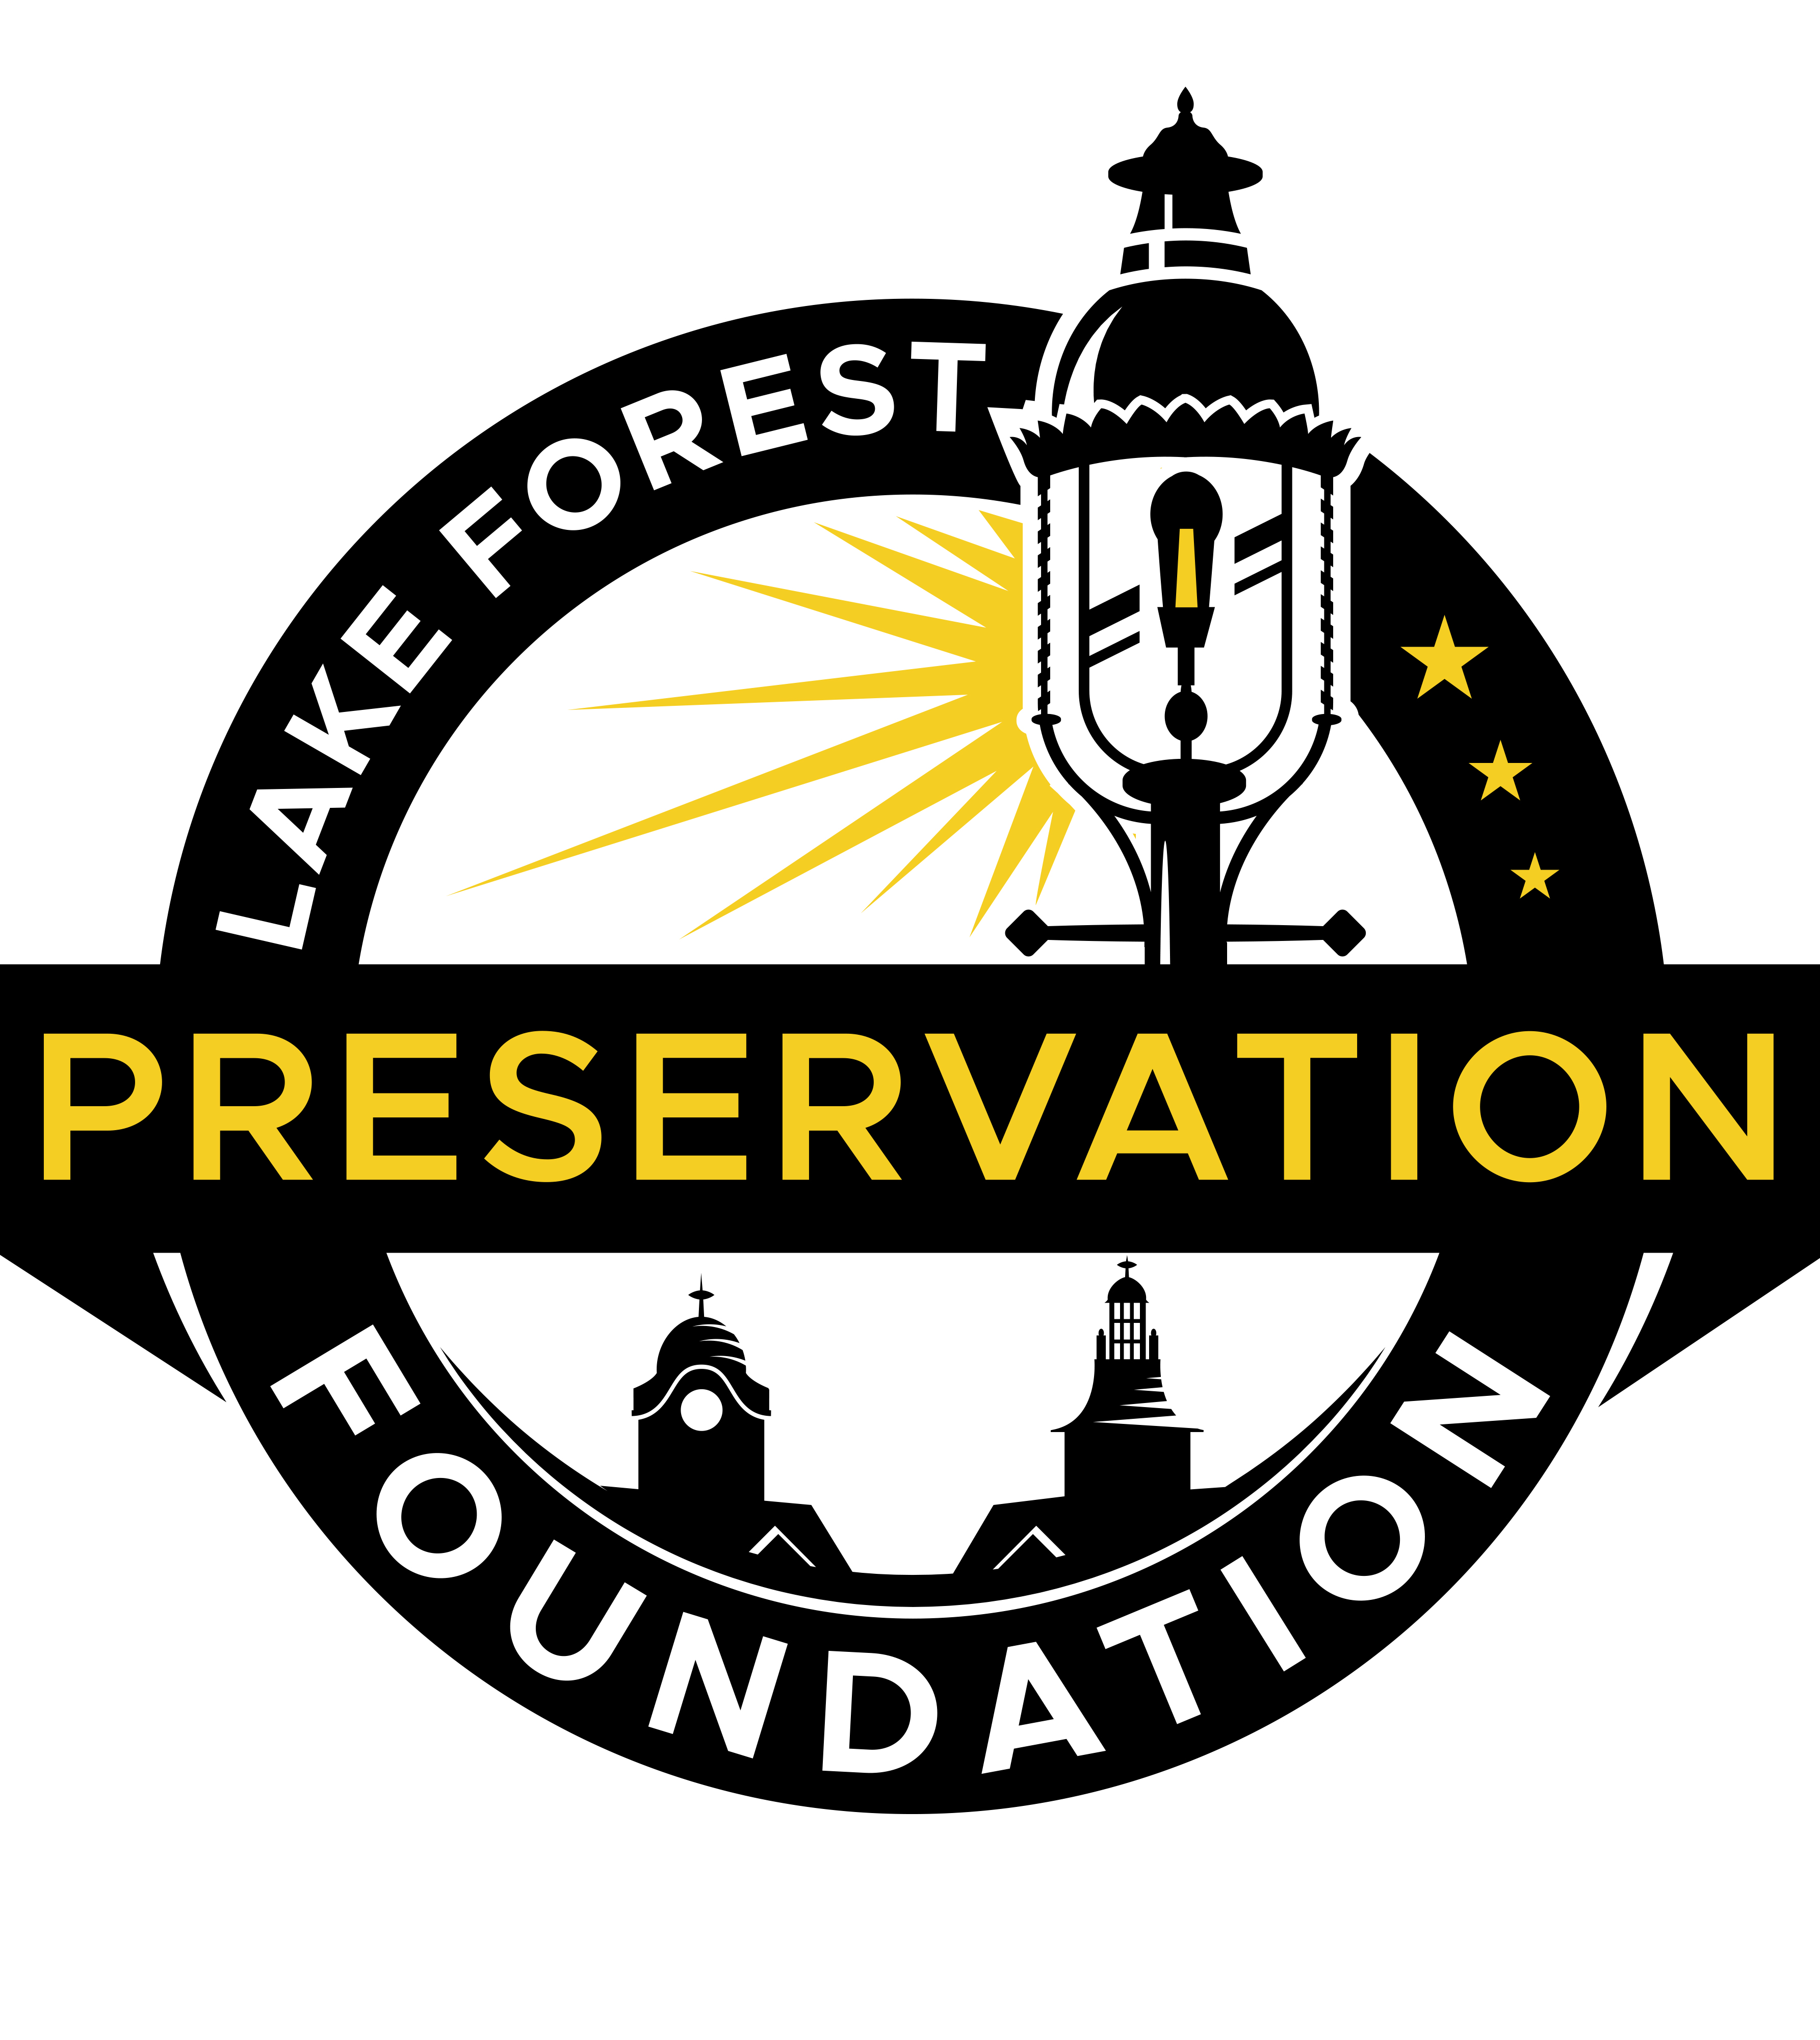

11/5/2022 review of Plan Commission petition
Over one year ago, 361 Westminster, LLC and 705 N. McKinley Development, LLC (the “Developer”) filed a lawsuit against, among others, the City of Lake Forest, the Historic Preservation Commission, the Lake Forest Preservation Foundation, and individual residents, in connection with the denial of a certificate of appropriateness for Phase 3 of the McKinley Rd. Condominium Development (“Phase 3”). The Developer asked the Court to reverse that decision and award money damages against the City for allegedly breaching the Purchase and Sale Agreement under which Developer contracted to purchase 361 Westminster from the City. Over the last year, the Court dismissed the Developer’s claim for breach of contract and set a hearing in December 2022 on its claim for an administrative review of the decision to deny a certificate of appropriateness for Phase 3. Last week, the City Council approved a conditional settlement of the lawsuit with the Developers.
To understand the settlement, some background may be helpful. In 2016, the Plan Commission, with public input, adopted a Master Redevelopment Plan for the McKinley Rd. project, which envisioned two condominium buildings along McKinley Rd. (Buildings 1 and 2) and a third condominium building behind them (Building 3), which would extend no further North than Building 1. In addition, on a portion of 361 Westminster that fronted Westminster, the Master Plan called for a separate lot of approximately 10,000 SF for a single-family home or duplex.
Through this layout, the 2016 Master Plan achieved at least two objectives important to the community. First, a house or duplex would preserve the historic residential streetscape of Westminster, which is one of the main entrances to the East Lake Forest Historic District and the Lakefront. Second, by setting the Phase 3 building even with Building 1 and well behind the single-family home or duplex facing Westminster, the mistake that occurred with respect to 351 E. Westminster – where the historic house was “saved” but the condominium built directly behind overpowered the residence – would not be repeated.
Following the Developer’s purchase of property at 373 E. Westminster, which was directly East of Phase 3, the proposed development changed dramatically. Instead of a single-family home fronting Westminster, the Developer sought approval of a much larger condominium building in the style of Buildings 1 and 2 that would extend North beyond Building 1 and directly front Westminster. The Lake Forest Preservation Foundation, neighbors and the community at large vehemently opposed the proposal, which substantially deviated from the consensus of the community as reflected in 2016 Master Plan.
By a 6-1 vote, the HPC denied Developer’s petition because the proposed structure failed to satisfy the 17 standards applicable to construction in the East Lake Forest Historic District. In general, it simply was not compatible with the historic residential homes on Westminster to which it visually related. The Developer appealed the HPC’s decision to the City Council, which denied the appeal and upheld the HPC’s decision, albeit by a narrow margin, 4-3. At that time, the Lake Forest Preservation Foundation submitted a memorandum to the City Council in support of the HPC’s decision and offered an alternative: Developer should construct a single-family home on the front lot facing Westminster with the condominium behind it, consistent with the 2016 Master Plan. At that time, the Developer rejected this suggestion and instead proceeded with the lawsuit against the City and all those who publicly voiced their views at the City Council meeting.
More than one year later, having failed to prevail on any claims, Developers agreed to settle with the City by proposing to put a single-family home on the lot facing Westminster with Building 3 behind it, subject to review by both the Plan Commission and the HPC. As part of the settlement, the City also agreed, among other things, to (1) reduce the purchase price of 361 Westminster from $500,000 to $250,000, (2) reimburse the Developer for up to another $250,000 to bury the power lines, and (3) release the Developer from the contractual obligation to create parking spaces for the Library on a portion of the property.
While the Lake Forest Preservation Foundation believes that the proposal to build a single-family home on the portion of the lot facing Westminster – subject to full review by the HPC and the Plan Commission – is a positive development, it has the following issues with the proposed settlement which continues to deviate markedly from the 2016 Master Plan:
- The foot print for Building 3 is now much larger than originally proposed by approximately 4800 SF.
- The increase in square footage is all directly behind the proposed single-family home with the proposed Building 3 being constructed approximately 60 feet further North than Building 1 and right on the lot line of the proposed home, which would violate setback rules, overpower the proposed single-family home and detract from the historic integrity of the surrounding area.
- While the proposal leaves out key details such as height, design, or roof shapes, among other things, the footprint suggests that it will remain the same undifferentiated two-story structure as before with roof top living that simply does not comply with the HPC standards.
- There is no compelling explanation or justification for why the City reduced the purchase price or relieved the Developer from its obligation to build parking spaces for the Library.
- There are no safeguards in place to protect the neighbors and community during the building process.
The City Council assured members of the public, when it voted to accept the settlement, that it was conditioned on full, complete and independent reviews by the Plan Commission and the HPC, which would be guided only by the standards they are obligated to uphold. This being so, it is imperative that members of the community voice their opinions with regard to Phase 3 to the Plan Commission at its meeting on November 9th, and to the HPC at its meeting on November 16th. Any comments or questions regarding the settlement should be directed to your Aldermen, the Mayor, and/or the City Manager.
Based on what we know now, the Lake Forest Preservation Foundation expects to oppose the Phase 3 development for the reasons set forth above. Absent significant changes, the proposed condominium building it is at odds with the 2016 Master Plan and fails to comply with the 17 HPC standards. Due to the absence of style cues and variety as on the similarly shaped north and south Market Square buildings, the condominium is overbearing from the street and east, since it most likely will sit up higher than the house. Like Market Square, the north and east facades could add some interest and variety to match the anti-modern character of nearby residences. While style cannot be dictated under current criteria, compatibility on the streetscape is. The problem will be mitigating the impact of cliff-like night-glowing walls absent some architectural devices wholly absent from earlier iterations of Phase 3.
In addition, to the extent that a home and condominium are ultimately proposed that do meet these standards, conditions should be adopted to minimize the impact on neighbors who have endured this project for too long, including, among other things, (1) building the proposed homes first, (2) barring any roof top living space, and (3) planting mature trees and hedges to screen the condominium building.

